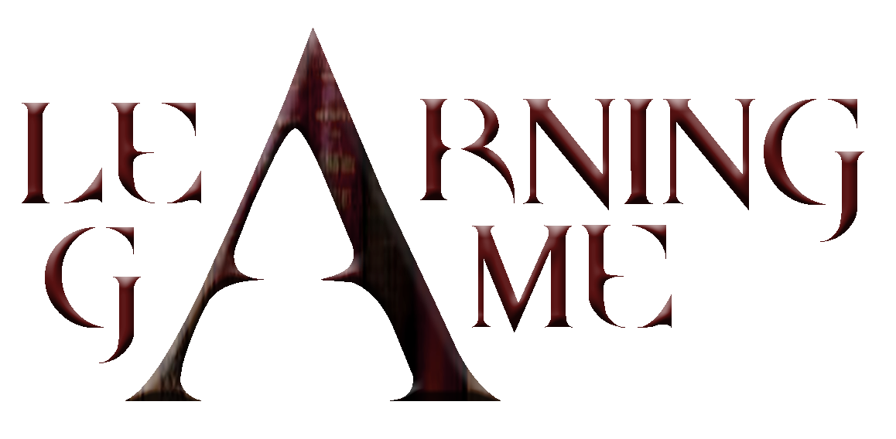

1st Teachers’ National Workshop

Patras, Univeristy of Patras



Report on the 1st Teachers’ Workshop

The University of Patras, Computer Engineering and Informatics Department hosted the 1st National Learning Game Teachers’ Workshop. The workshop was organised on the 31st of January and the venue was the Graphics, Multimedia and GIS Lab premises in the Department of Computer Engineering and Informatics.

The aim of the workshop was to introduce the idea of the Learning Game project to the participating schools in the region of Achaia and Aitoloakarnania in the West Region of Greece. This was the scope of the 1st presentation made by Assistant Professor Spiros Sirmakessis. The teachers raised a lot of questions on the practical issues for applying the methodology to the greek schools and the greek educational system. Despites these problems the idea seemed to them very impressive and the expressed their strong interest in being part of this trial and join our efforts.

The agenda of the workshop included demostration of tools used for game production. Mr Marios Katsis, Msc, presented video editing tools that can be used to create video clips. The agenda included the production of a video clip by the tutor. Mr Katsis used a common video camera to grab some clips and step by step produced a small clip containing home video clips, personal photos, commercial mp3 music files, narration clips, subtitles and credits.

Following, Mr Kostas Markellos, Msc, started the 1st part of his demonstration on image processing. The scope ot the 1st part of his presentation was to introduce teachers in the first theoretical framework of image peocessing. Following that a demostration of about 90’ minutes was made on the way teachers can use freeware tools to proper organise their raw photo materials in order to be used during the 2nd part of his demonstration, scheduled for the 2nd workshop.

The feedback from the teachers was quite positive. The important issue of the 1st workshop was to convience them about the Learning Game idea and show them some first tools and demonstrate the use of functions that can apply to game design and production.

At the end of the workshop, teachers received a participation certificate.

Attached documents
- 1st Workshop Agenda
- List of Participants
- Learning Game Presentation
- LG Brochure
- LG Dissemination Material
- LG Workshop Participation Certificate
- Photos of the event

